**NAME: EDITH NJOKI WANGUIS**

**EMAIL ADDRESS: edith.wangui@womentechsters.org**

**PRACTICAL ACTIVITY 1 AND 2**

**ACTIVITY 1**

My username is: Ubuntuuser1

1. Processes for the current shell

Commands used: -$ ps

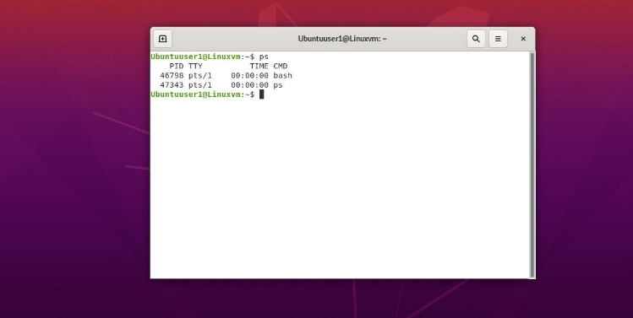

1. Displaying information about processes

Command used: -$ ps aux

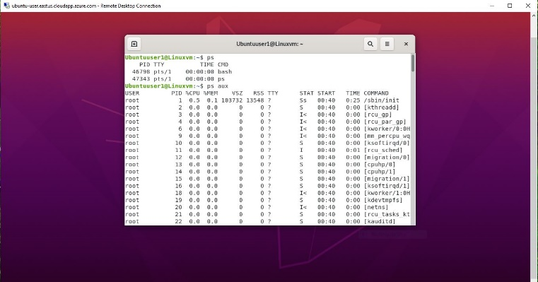

1. Global priority of a process and the column that provides it

Command: -$ ps ecl column PRI

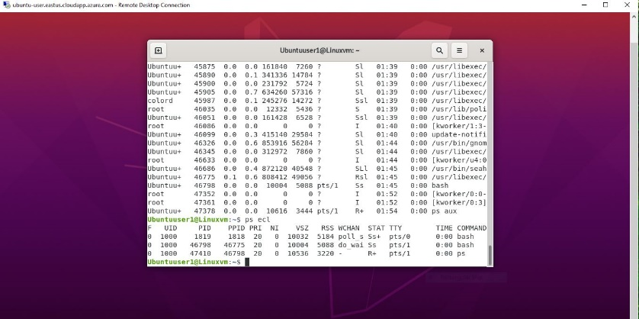

1. Change priority of a process with default arguments

Commands: -$ ps –al

Column NI

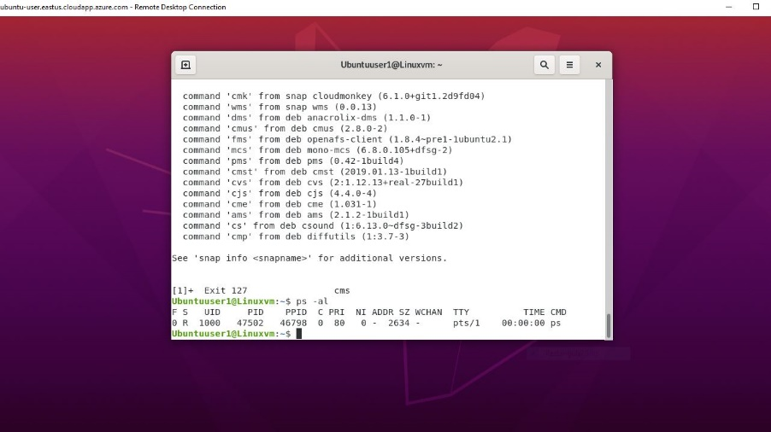

1. Display virtual memory statistics

Commands: -$ vmstat

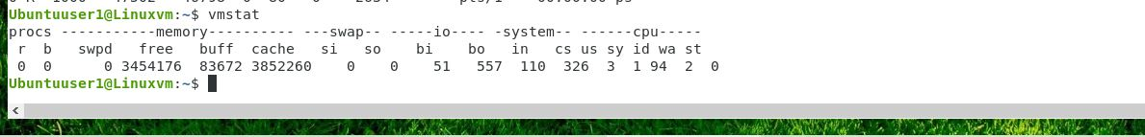

1. System event information and
2. Swapping statistics

Commands for 6 and 7: -$ top

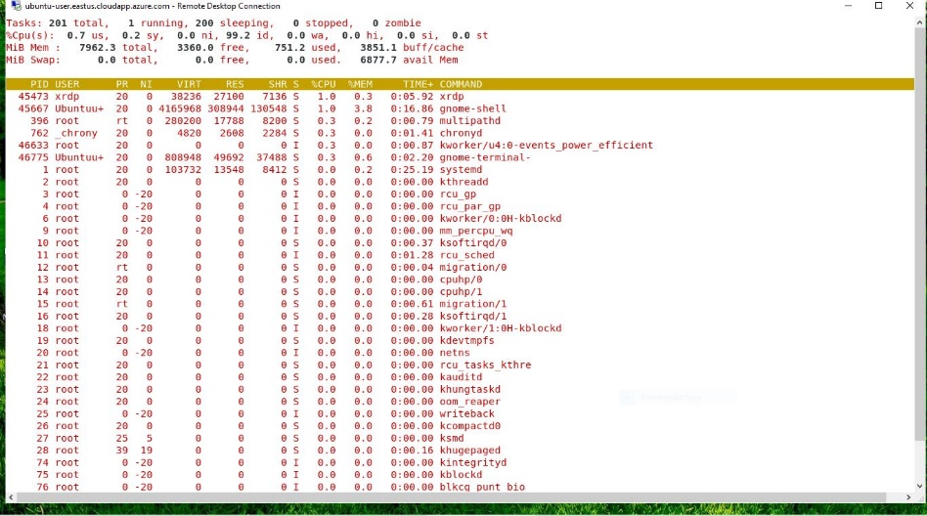

1. Check file access statistics

Command: -$ sar -a

1. Buffer activity statistics

Commands: -$ sar -b

Both commands gave me an error. (Forgot to screenshot the errors)

1. Disk activity statistics

Command: -$ vmstat –d

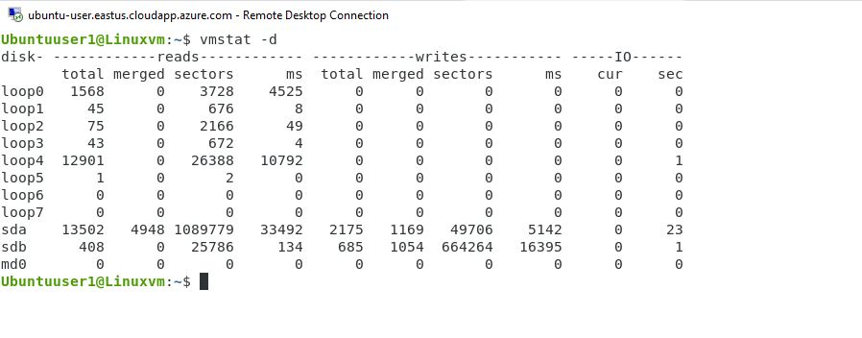

1. Check interprocess communication statistics

command:-$ htop

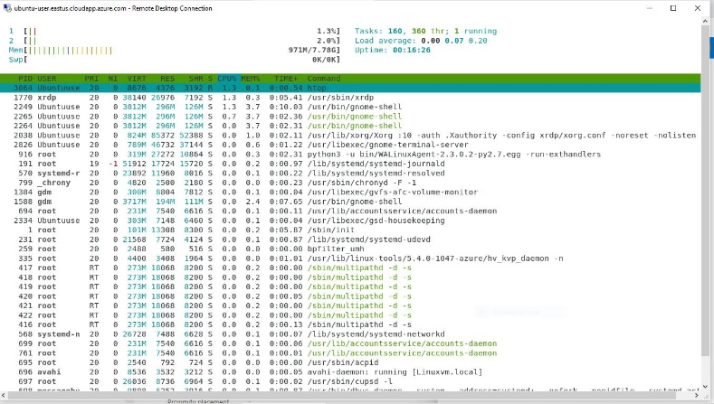

1. Unused memory in the server

Command: -$ free -m

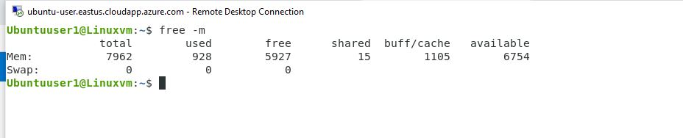

1. Swap activities

Command: -$ free –t –m

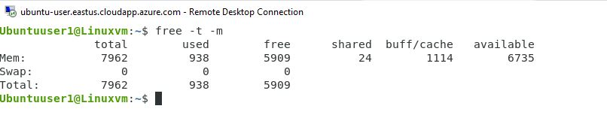

**ACTIVITY 2**

1. Creating user1 and user 2

User1 : Bob

User2: Ann

Command used: -$ sudo add user bob

Bob

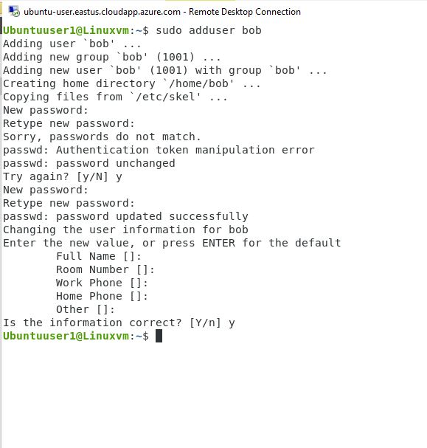

Ann

Command : -$ sudo adduser ann

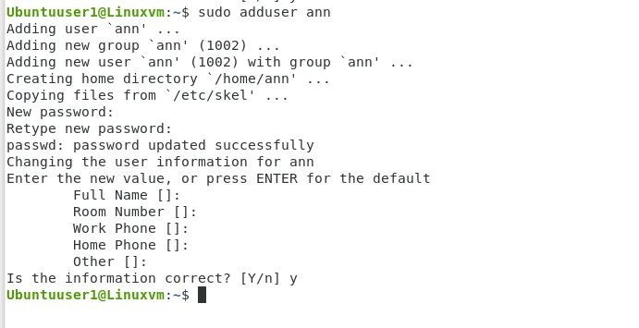

1. Ensuring that both Bob and Ann are protected

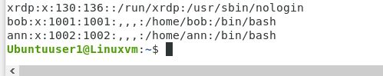

1. logged in as Bob (bob is my user 1)

Command: -$ su –l bob

Confirmed it’s bob with command: -$ whoami

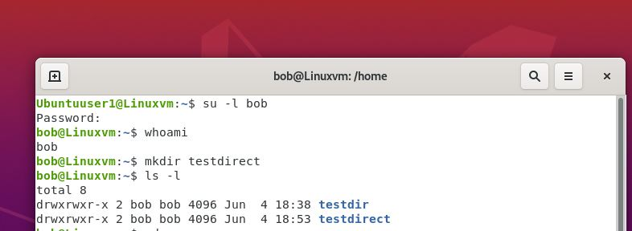

1. Creating a directory

Name : testdirect

Command: -$ mkdir testdir

To confirm its created used

Command : -$ ls –l

(testdir I created before- forgot to take screenshot – this is for testdirect directory)



1. Creating a testfile in testdir

Command: -$ cd testdir

: $ touch testfile.txt

To confirm its created :

Command: -$ ls

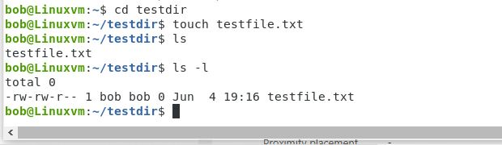

1. The ownership and the group of the testfile

Owner bob

Command: -$ ls -l



1. Switch to superuser account

Command:-$ exit

From bob to Ubuntu user1

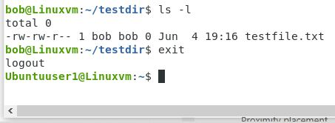

1. Creating a public directory 1

Name dir2

Created a group

Command: -$ sudo groupadd dirusers

Created directory

Command: -$ sudo mkdir/home/dir2

Changed group for the directory

Command: -$ sudo chgrp dirusers /dir/2/

Confirm

Command : -$ sudo ls –l /home/

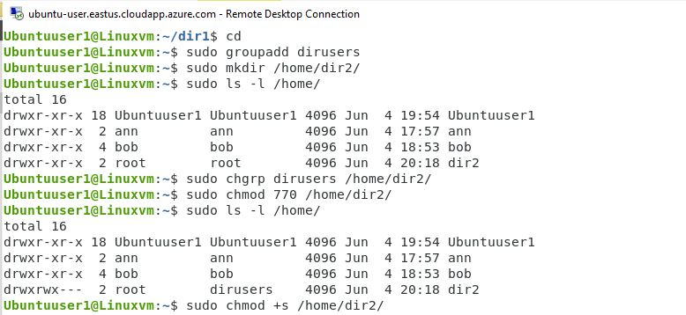

1. Set stickybit

Command : -$ sudo cmod 770/home/dir2



1. Logout login as normal user 1 i.e from ubuntuuser1 to Bob

Command : -$ su -l bob

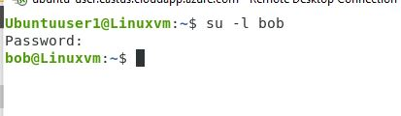

1. Creating a file userfile1 in dir2

Command: -$ cd dir2

$ touch userfile.txt

Confirm it’s there

Command :-$ ls

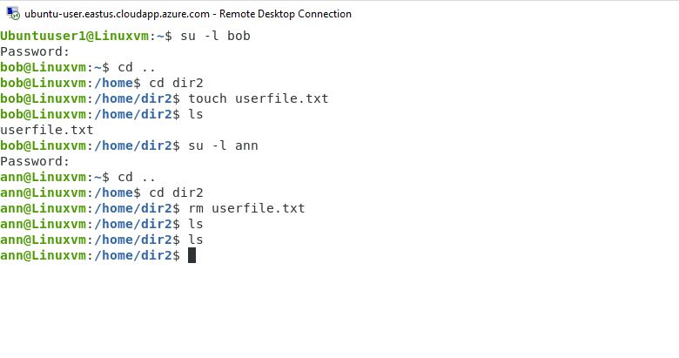

1. Login as user2 i.e Ann

Command: -$ su –l ann



1. Tried to remove the file (userfile.txt)

Command: -$ rm userfile.txt

It executed and the file disappeared

To confirm

Command:- $ ls



1. Temporary disable user logins

Command:- $ passwd bob -l

$ passwd ann -l

Result: permission denied

When enabling back the user the –u command failed

Command :-$ passwd bob -u

